Nepal College of Information Technology
Balkumari, Lalitpur
Assessment Fall-2013

Level: BE (CE/Elx.) F.M: 100
Course: Network Theory P.M:45 Time: 3 hours

- Candidates are required to give their answers in own words as far as practicable
- Attempt all the questions
- The figure in the margin indicate full marks

1. a) In the following circuit, switch S is changed from position ‘a’ to ‘b’ at t=0. Find values of [7]
at

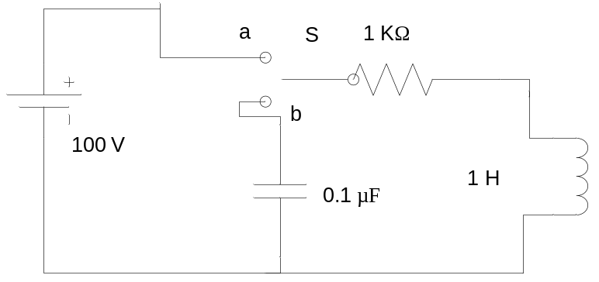
b) The circuit shown in figure has been in steady state for a long time with the switch ‘S’ open. Determine the complete solution for the current when ‘S’ is closed at t= 0. Use classical approach. [8]
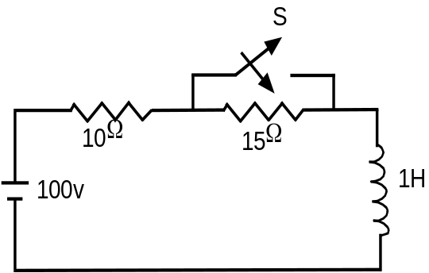

2. a) In the given circuit below, capacitor C has an initial voltage V_{C} (0⁻ ) = 10 Volts and at the same instant current in the inductor L is zero. Switch k closed at time t=0. Obtain expression for the voltage v(t) across the inductor L using classical approach. [8]
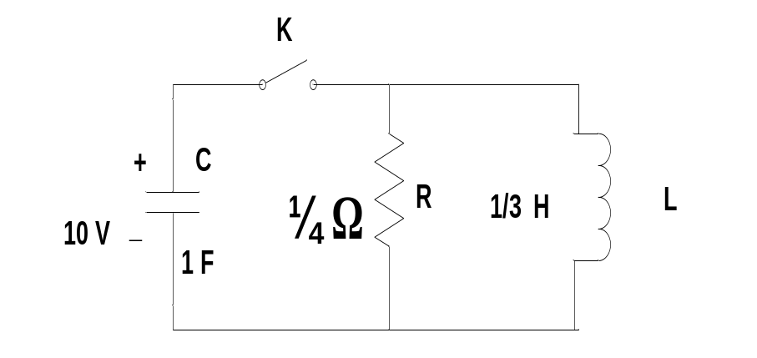
b) An exponential voltage is applied at time t=0 to a series R-L circuit comprising a resistor R= 4 Ω and inductor L= 1 Henry. Obtain the particular solution for current i(t) through the circuit using classical approach. Switch K is closed at time t=0. Assume zero current through the inductor before switching. [7]
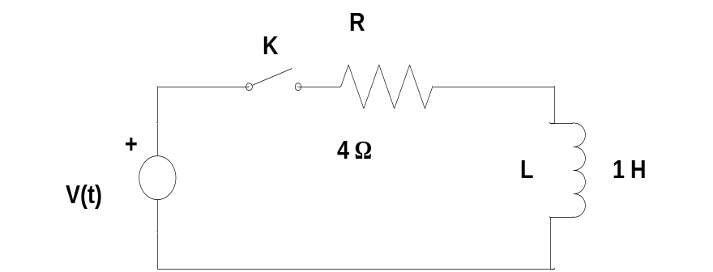
3. a) An exponential current 2e^{-3t} is applied at time t=0 to a parallel R-C circuit comprising resistor R=1/2 Ω and capacitor C= 1 farad. Obtain complete particular solution for voltage v(t) across the network by using Laplace Transformation .Switch K is opened at time t= 0. Assume zero charge across the capacitor before the application of current. [8]
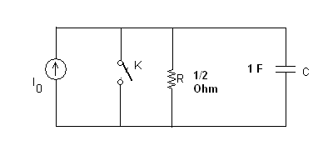
b) Using Laplace transform function solve the following differential equation. [7]
. Given that ,
4. a) Determine the range of K so that the system given by characteristics equation
is stable. Use Routh’s Tabulation. [7]
b) Draw asymptotic Bode plot for the following function: [8]
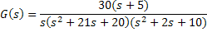

5. a) List the properties of Positive Real Function (PRF) [7]
b) Realize the R-C admittance in Foster-II form. 8
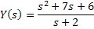

6. a) Which of the following functions are L-C driving point impedances? Why?
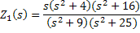

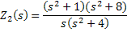
And, synthesize the realizable impedances in a Foster –I form. [8]

b) Find the trigonometric Fourier series for the waveform shown in figure below: [7]
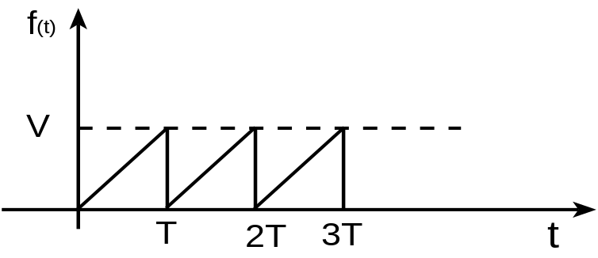

7. Write short notes on: (Any two) [2×5]
- Filter and its types
- General Guidelines in evaluating initial conditions in network
- Advantages of Laplace transform over classical approach

